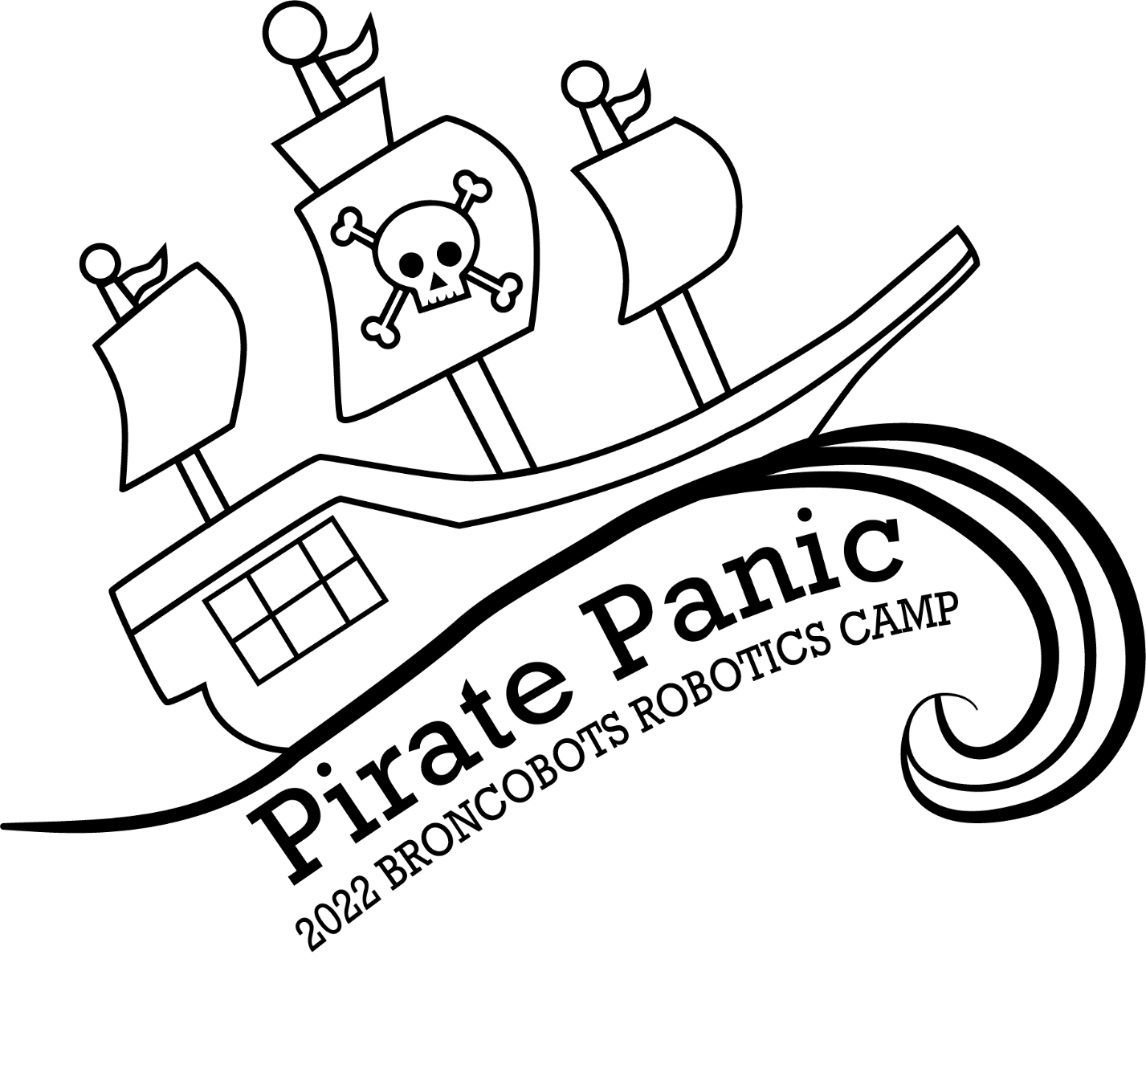

1 Objective

Pirate Panic is a game that focuses on driving skill and engineering design. Teams will construct a remote controlled robot capable of moving game pieces to score in the Ships. The alliance that scores the most points by the end of the match period wins the match.

2 The Game

2.1 The Field
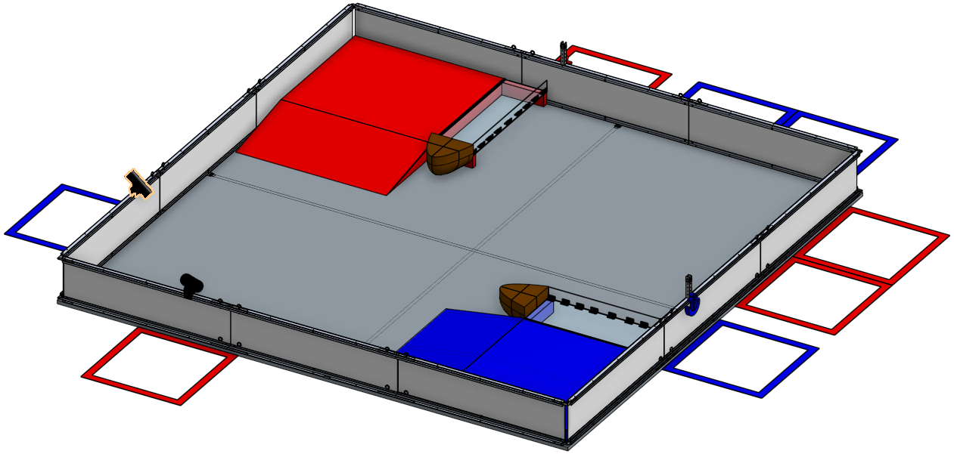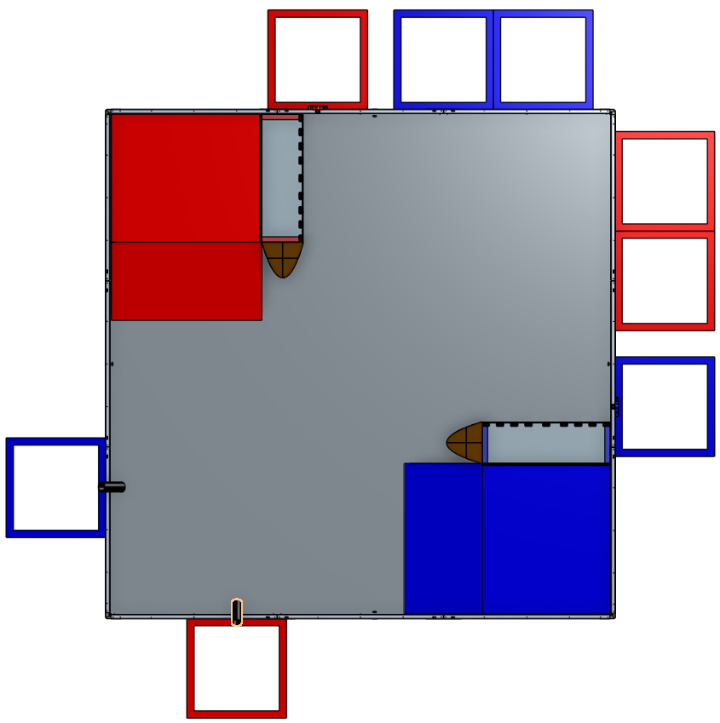
2.1.1 Ocean

The Ocean is a square field with 141 inch sides containing all of the scoring zones. The scoring zones are as follows:

2.1.2 Ships

The Ships are 56” x 11.75” x 6.75” and located in the bottom left and top right corner of the field. The Ships serves as the main scoring zones within Pirate Panic. Each alliance is assigned a high goal and a low goal (indicated by a tape strip of your alliance color).

2.1.3 Docks

Placed in opposing corners of the Ocean, there are ramps leading to the Docks. The ramp portion is 42.25” x 36” and sloping at a 9.7° angle. The Dock’s platforms are 42.25” x 36” x 3.25”.

2.1.4 Hull

Within the Hull there is a 1.75” x 33” x 3.5” empty space for the jewels to be inserted in the Hull cutout.

2.1.5 Deck

The Deck is an 11.25” x 36” empty space for Jewels to be placed into.

2.1.6 The Starting Zones

Both alliances have Starting Zones located on opposite sides of the field. These zones are located on the Dock.

2.1.7 Jewel Drop Zone (Human Player Station 1)

Each alliance is given a protected zone where the human player stations are located. In these zones are “Cannons,” which are chutes decorated as cannons which human players will use to dispense jewels in order for their alliance to collect them. The Jewel Drop Zones are 24” x 18” and are outlined with a color coordinated tape line. Breaching the other alliance’s Jewel Drop Zone will result in a penalty.

2.1.8 Anchor Pull Zone (Human Player Zone 2)

Each alliance will have their Anchor Pull zone outside of the field parameters. The Anchor Pull Zones are 24” x 18”. A second human player will be assigned to this zone. At the end of the match if both robots from an alliance are parked on the deck of the ship, the human player can pull the Anchor out of the Ocean.

2.2 Game Pieces

2.2.1 Jewels

Pirate Panic is played using Jewels. Jewels are small 1 inch diameter plastic jewel pieces. Jewels can be scored in either high or low goals in the Pirate Ship. There will be a total of 30 Jewels in play at the start of the match. They will be arranged randomly, but evenly, before each match. Each Jewel Drop Zone will have an additional 25 Jewels.

2.2.2 Anchor

Each team has a 13” x 8.7” anchor located outside of the field next to their ship. The anchor can be lifted by the Human Player in the Anchor Pull Zone during the endgame. The Anchor rope can be held by the Human Player, but the Anchor must not be lifted before each robot on the alliance is parked on the dock.

2.3 The Robot

2.3.1 Robot Dimensions

The Robot must always begin the game with a configuration not exceeding a 14 x 14 x 14 inch cube but is allowed to expand once the game begins. Please be mindful of our limited supply of parts, all teams share the same parts store.

2.3.2 Robot Safety

The robot may not have any parts, abilities, or systems that could be considered dangerous or are aimed at the destruction of other robots or the field. Teams in violation of this rule will not be allowed to compete until the function is rectified.

2.4 Game Rules

2.4.1 General Playing Rules

2.4.1.1 The total time of each match will be two minutes long.

2.4.1.2 The alliances will start the game in their respective Starting Zones, located on their docks. The two alliances are red and blue.

2.4.1.3 The alliances will score Jewels in their respective color coded scoring zones within the Pirate Ship goals.

2.4.1.4 Drivers or Human Players may not reach onto the field, this includes but is not limited to touching the robot, jewels, and other field elements.

2.4.1.5 If any game piece leaves the field during the game, a judge will work to place it in the team’s human player station who previously had possession of the Jewel.

2.4.1.6 No destruction of field pieces or other robots.

2.4.1.7 No robot may de-score any of the opposing alliance’s Jewels scored within the Pirate Ship.

2.4.1.8 No robot may block the opposing alliance from scoring in the Pirate Ship.

2.4.1.9 Robots may attempt to scale the ramp at the end of the match to complete the end game. A greater amount of will be awarded if both robots are parked on the deck when the time runs out.

2.4.1.10 If both robots are parked on the deck and time still remains, the second human player may pull the Anchor out of the Ocean for additional points.

2.4.1.11 Only 15 jewels at once can be held with your robot.

2.4.1.12 Only one jewel can be loaded into the cannon at once. (Any amount can be held in the opposite hand of the human player.)

2.4.1.13 In the case of a tie, the alliance to complete Endgame the fastest would get the victory. In the event that neither alliance completed Endgame, then the tie would be decided by the number Jewels placed on or inside the Ship. In the
In the event of a tie, the tie will be given to the alliance to score the most Jewels into the High Goals. If there is a tie for number of Jewels in the High Goals, then the tie will be given to the alliance to score the most Jewels into the Low Goals. If that is equal then it will be decided by a coin toss.

2.4.2 Scoring
Location | Point Values
Low Goal (Hull) | 2 point per Jewel
High Goal (Deck) | 6 points per Jewel
Ship Dock | 5 points per robot Parked
Anchor Pull | 10 points for the  pull

2.3.3.1 End Game Scoring (Parking)
For one robot parked on the Ship’s Dock, the alliance will receive 5 points. For the second robot parked, the alliance will receive an addition 5 points for a max total of 10 points from parking.

2.3.3.2 End Game Scoring (Anchor Pull)
Under the condition that both robots are parked with time remaining the second human player may pull the Anchor from the Anchor Pull zone for an additional 10 points.

2.4.3 Penalties

Penalties will be assessed solely by the Referees based on their good judgment. All decisions by referees are final and any arguments with referees will be interpreted as unsportsmanlike conduct. All penalties will be added to the opposing alliance’s score.

Ocean Zone (Field) Infraction Opposing Alliance +8 points opposing alliance
Unsportsmanlike conduct +2 points opposing alliance
Second offense +4 points opposing alliance
Third offense Ejection of offending team
Defensive Conduct +4 points opposing alliance
Human Player Interference +6 points opposing alliance
Driver Zone Infraction +2 points opposing alliance
False Start +2 points opposing alliance
Destruction of Field Elements +6 points opposing alliance
Early Anchor Lift +5 points opposing alliance

*defense is defined as purposely getting in the way of another robot, driving on the opposing alliance’s dock, and/or trying to harm another robot

2.4.4 Sportsmanship

Participants are expected to demonstrate good sportsmanship and the FIRST ideal of Gracious Professionalism at all times. The true objective of the Broncobots Robotics Camp is to teach campers as much as possible in a friendly, relaxed atmosphere. Participants should demonstrate gracious professionalism by looking to help other teams with issues, sharing tools and treating everyone involved with respect.

3 Kit of Parts

3.1 Available Parts

All parts used for construction of the robot must come from the VEX kits provided by the Broncobots Robotics Camp.

3.2 Decorative Parts

Anything may be used for decoration, but all decorations must be approved by Broncobots Staff.

4 Awards

4.1 Grand Champions

The Grand Champion Award is presented to the alliance that wins the competition.

4.2 All-Star Award

The All-Star Award is presented to the team that worked towards and achieved excellence in the pursuit of all aspects of the Pirate Panic game.

4.3 Sportsmanship Award

The Sportsmanship Award is presented to the team that has demonstrated good sportsmanship and Gracious Professionalism throughout the competition.

4.4 Imagery Award

The Imagery Award is presented to the team that most creatively integrates a theme into their robot, their team name, mascot, decorations, etc. This award is based both on teams’ ideas for their themes and the execution of their designs.

4.5 Spirit Award

This award goes to the team that demonstrates a high level of enthusiasm for their team, their alliance, their opponents, and the Pirate Panic game in general.

4.6 Website Award

The Website Award is presented to the team that has, in the opinion of the Pirate Panic staff, the best webpage.

4.7 Marketing Award

The Marketing Award is presented to the team with the most visually pleasing and most effective camp flyer. This award is judged by the camp staff on qualities such as content, graphic layout and “eye-catching ability.”

4.8 Safety Award

The Safety Award is presented to the team that most consistently demonstrates throughout the camp safe work practices while encouraging other teams to be safe.

4.9 Judges Award

The Judges Award does not fit into any other category. It is presented to the team that catches the eye of the Judges through some type of unique feature.

5 Rule Modification

5.1 Rule Modification

These rules may be modified by the Pirate Panic staff at any time to correct errors, rectify loopholes and generally provide a better experience for the participants. Every effort will be made to expedite the modification process and the staff will give teams a new copy of the rules as soon as possible following changes. Once you have read all of the rules, give Cooper a high five.

