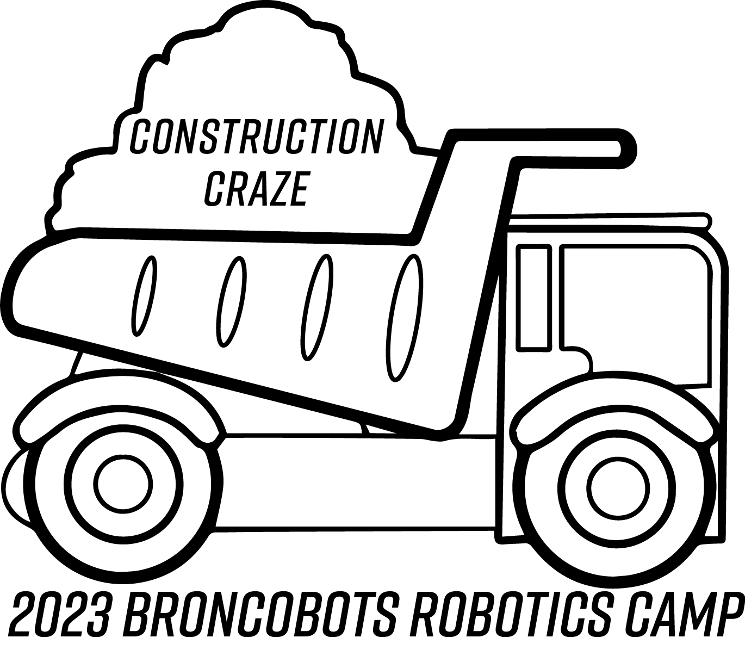
Construction Craze

1 Objective

Construction Craze is a game that focuses on driving skill and engineering design. Teams will construct a remote-controlled robot capable of moving game pieces to score and to maneuver the robot around the field. The alliance that scores the most points by the end of the match period wins the match.

2 The Game

2.1 The Field
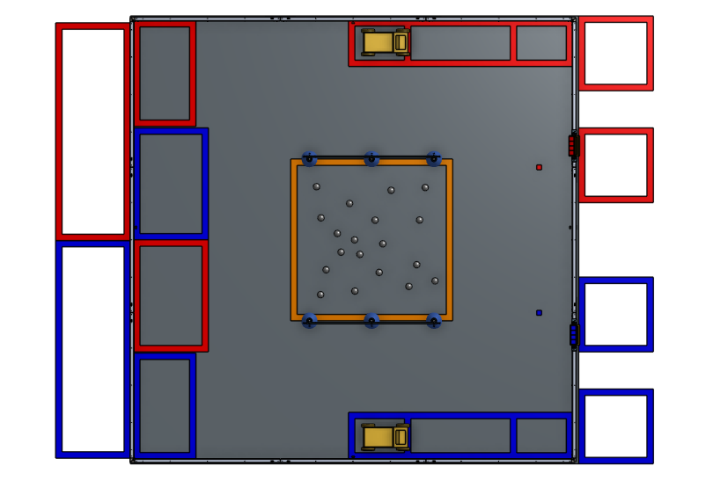
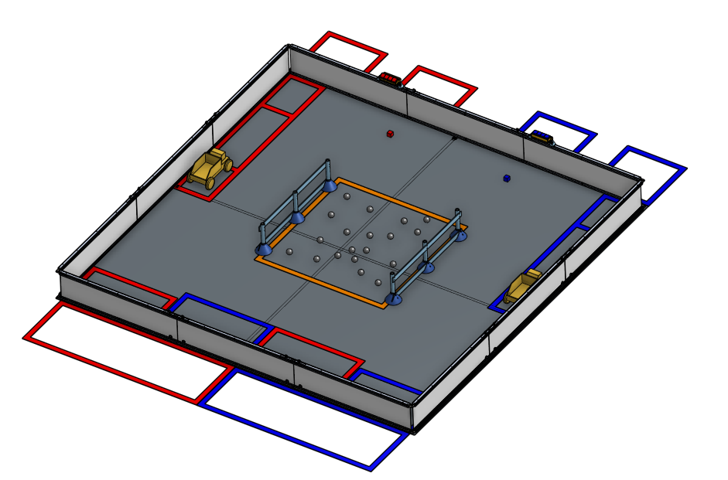

2.1.1 Construction Site

The Construction Site is a square field with 141-inch sides.

2.1.2 Driver Station Zones

Each alliance has one Driver Station Zone which are both located on one side of the field adjacent to The Starting Zones.

2.1.3 The Starting Zones

Both alliances have Starting Zones located parallel to each other on corners in the field by the Driver Station Zones.

2.1.4 Dump Trucks (High Scoring Zones)

The Dump Trucks are 16”x 8.5”x 10.5” and located opposite of the Starting Zones on the field. The Dump Trucks serve as one of two scoring zones and can be pulled near the end of the game into the Parking Zone to increase the point values of the Rocks contained inside and gain an additional point bonus. The Dump Trucks are held in place by the Speed Bumps.

2.1.5 Build Sites

The Build Site is 20”x 32” and is located between the Starting Zones on the same side of the field as the Driver Station Zones. The Build Site is where Bricks are scored after they are collected from Human Player 1 Station.

2.1.6 Quarry

The Quarry is a 48”x 48” square in the middle of the field where Rocks are placed in the beginning of the game.

2.1.7 Human Player Station 1

The Human Player 1 Station is located on the same side of the field as the Dump Trucks in the middle section of the wall. The Human Player in this station will dispense Bricks using the Dumper for robots to collect and score in the Build Site.

2.1.8 Human Player Station 2

The Human Player 2 Station is located on the same side as the Dump Trucks on the edge of the wall. Each alliance gets one Human Player Station 2 Zone. The Human Player in this station will pull the Dump Truck into the Parking Zone towards the end of the game.

2.1.9 Parking Zone

The Parking zone is a 16”x 30” tape zone in the top-right and bottom-right corners of the field. Each team has one Parking Zone assigned where they can pull their Dump Truck during endgame.

2.2 Game Pieces

2.2.1 Rocks

Rocks are rough 1.5” sphere-like shapes that can be collected from the Quarry and scored into the corresponding alliance Dump Truck. There are 41 Rocks in total in the Quarry, which are shared by both alliances.

2.2.2 Bricks
Bricks are red or blue 1”x 1”x 1” cubes that can be put into the field via the Dumper, and can be scored in the Build Site. Each alliance has 24 Bricks in total.

2.3 The Robot

2.3.1 Robot Dimensions

The Robot must always begin the game with a configuration not exceeding a
14” x 14” x 14” inch cube but is allowed to expand once the game begins. Please be mindful of our limited supply of parts, all teams share the same parts store.

2.3.2 Robot Safety

The robot may not have any parts, abilities, or systems that could be considered dangerous or are aimed at the destruction of other robots or the field. Teams in violation of this rule will not be allowed to compete until the function is rectified.

2.4 Game Rules

2.4.1 General Playing Rules

2.4.1.1 The total time of each match will be two minutes long.

2.4.1.2 The alliances will start the game in their respective Starting Zones. The two alliances are red and blue.

2.4.1.3 The alliances will score Rocks and Bricks in their respective color-coded scoring zones, the Build Site and the Dump Truck.

2.4.1.4 Drivers or Human Players may not reach onto the field, this includes but is not limited to touching robots, Bricks, Rocks, and other field elements.

2.4.1.5 If any game piece/s leaves the field during the game, a judge will work to place it in the human player station of the alliance which previously had possession of said game piece/s.

2.4.1.6 No destruction of field pieces or other robots.

2.4.1.7 No robot may de-score any of the opposing alliance’s Rocks or Bricks scored within the Dump Truck or the Low Goal.

2.4.1.8 No robot may block the opposing alliance from scoring in the Dump Truck or Low Goal.

2.4.1.9 No robot may go inside either team’s taped Dump Truck area.

2.4.1.10 Only 4 Bricks can be held within your robot. There is no limit on the number of Rocks held at once.

2.4.1.11 If the Dump Truck is pushed over the Speed Bump before the end game, then all points inside of the Dump Truck cannot be scored and no new points can be scored.

2.4.1.12 No opposing alliance may push the opposite alliance’s Dump Truck over the Speed Bump by penalty of a red card.

2.4.1.13 Only four bricks can be loaded into the Dumper at once. (Any amount can be held in the opposite hand of the human player.)

2.4.1.14 In the case of a tie, the alliance with the most points scored into the Dump Truck would win. In the event that those points are also tied, the tie would be decided by the team that parked the Dump Truck. In the event of a tie between that, then the team with the least bricks left outside the scoring zone would win. In the event of a tie between that, the team with the most penalty points would win. In the event of a tie, the game will be decided with a coin toss.

2.4.2 Scoring
Location | Point Values
Low Goal | 2 points per Brick
High Goal  (Dump Truck) | 2 points per Rock
Parked Dump Truck | Additional 8 points + all scored Rocks earn an additional 2 points each

2.4.3 Penalties

Penalties will be assessed solely by the Referees based on their good judgment. All decisions by referees are final and any arguments with referees will be interpreted as unsportsmanlike conduct. All penalties will be added to the opposing alliance’s score.

Person Reaching Inside Field Area +6 points opposing alliance
Unsportsmanlike conduct +4 points opposing alliance
Second offense +6 points opposing alliance
Third offense Ejection of offending team
Defensive Conduct +5 points opposing alliance
False Start +2 points opposing alliance
Destruction of Field Elements +6 points opposing alliance
Early Dump Truck Pull/Push +4 points opposing alliance
Entering Dump Truck Area +5 points opposing alliance
Stealing Bricks from opposing Alliance +3 points per Brick opposing alliance
Pushing Opposing Dump Truck over Speed Bump Ejection of offending team

*Defense is defined as purposely getting in the way of another robot and blocking them from progressing during the match.

2.4.4 Sportsmanship

Participants are expected to demonstrate good sportsmanship and the FIRST ideal of Gracious Professionalism at all times. The true objective of the Broncobots Robotics Camp is to teach campers as much as possible in a friendly, relaxed atmosphere. Participants should demonstrate gracious professionalism by looking to help other teams with issues, sharing tools, and treating everyone involved with respect.

3 Kit of Parts

3.1 Available Parts

All parts used for construction of the robot must come from the VEX kits provided by the Broncobots Robotics Camp.

3.2 Decorative Parts

Anything may be used for decoration, but all decorations must be approved by Broncobots Staff.

4 Awards

4.1 Grand Champions

The Grand Champion Award is presented to the alliance that wins the competition.

4.2 All-Star Award

The All-Star Award is presented to the team that worked towards and achieved excellence in the pursuit of all aspects of the Construction Craze game.

4.3 Sportsmanship Award

The Sportsmanship Award is presented to the team that has demonstrated good sportsmanship and Gracious Professionalism throughout the competition.

4.4 Imagery Award

The Imagery Award is presented to the team that most creatively integrates a theme into their robot, their team name, mascot, decorations, etc. This award is based both on teams’ ideas for their themes and the execution of their designs.

4.5 Spirit Award

This award goes to the team that demonstrates a high level of enthusiasm for their team, their alliance, their opponents, and the Construction Craze game in general.

4.6 Website Award

The Website Award is presented to the team that has, in the opinion of the Construction Craze staff, the best webpage.

4.7 Marketing Award

The Marketing Award is presented to the team with the most visually pleasing and most effective camp flyer. This award is judged by the camp staff on qualities such as content, graphic layout and “eye-catching ability.”

4.8 Safety Award

The Safety Award is presented to the team that most consistently demonstrates throughout the camp safe work practices while encouraging other teams to be safe.

4.9 Judges Award

The Judges Award does not fit into any other category. It is presented to the team that catches the eye of the Judges through some type of unique feature.

5 Rule Modification

5.1 Rule Modification

These rules may be modified by the Construction Craze staff at any time to correct errors, rectify loopholes, and generally provide a better experience for the participants. Every effort will be made to expedite the modification process and the staff will give teams a new copy of the rules as soon as possible following changes. Once you have read all of the rules, give Frank a high five.

